**Project Documentation: Process Optimization and UI Development with Python**

**Overview**

This project involved the development of a Python-based program to optimize 14 legacy processes that were previously manual, time-consuming, and prone to errors. The primary objective was to streamline these workflows, reduce redundancy, and enhance overall operational efficiency. The project included the creation of an intuitive user interface (UI) to enable non-technical users to execute these processes effortlessly.

**Objectives**

* **Streamline Workflows:** Automate repetitive tasks to reduce processing time and eliminate manual errors.
* **Enhance Efficiency:** Increase process execution speed and improve consistency across operations.
* **User Accessibility:** Develop a user-friendly interface to allow non-technical users to interact with complex processes easily.

**Methodology**

**1. Process Analysis**

The project began with a comprehensive analysis of the existing processes. I identified key bottlenecks and inefficiencies by mapping out each process step-by-step. This analysis provided the foundation for designing targeted automation solutions.

**2. Automation Script Development**

Using Python, I designed and implemented automation scripts tailored to each process. Key libraries utilized included:

* **Pandas:** For efficient data manipulation and transformation.
* **Other libraries** as needed to address specific process requirements.

These scripts replaced manual tasks, dramatically reducing processing time and minimizing human error.

**3. User Interface Development**

To ensure accessibility for non-technical users, I developed a user-friendly interface using the PyQt framework. The UI was designed with four primary sections:

* **Process Selection:** A dropdown menu for users to select the desired process.
* **File Browsing:** An interface to browse and select the folder containing files for processing.
* **Progress Monitoring:** A real-time progress bar displaying the status of the operation.
* **User Messaging:** A section that provides intuitive messages and feedback to guide the user through the process.

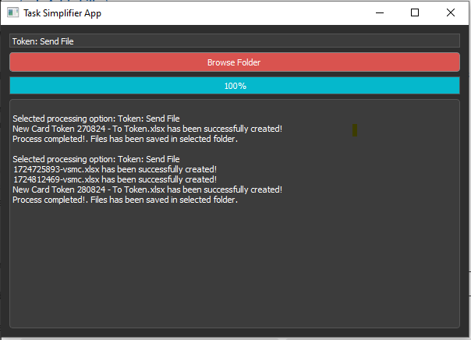

**4. Error Handling and Logging**

The UI was enhanced with robust error handling to manage unexpected issues gracefully. Logging mechanisms were implemented to capture detailed records of each process, facilitating troubleshooting and performance tracking.

**5. Stakeholder Collaboration**

Throughout the project, I collaborated closely with stakeholders to ensure that the automated processes aligned with business requirements and compliance standards. Regular feedback sessions were held to iterate on the design and functionality.

### ****Challenges****

One of the major challenges I faced during the project was the inability to fully automate the processes due to limited access to the Salesforce database. This restriction meant that some manual work was still required, specifically the downloading of files from Salesforce before they could be processed by the automation scripts. Despite this limitation, I ensured that the rest of the workflow was as streamlined as possible, minimizing manual intervention, and maximizing efficiency where automation was feasible.

**Results**

The project yielded significant improvements:

**Overall Improvement**

* **Efficiency Gains:** Some processes experienced up to a 70% reduction in execution time.
* **Consistency:** Automation led to more reliable and accurate outcomes, reducing the risk of errors.
* **Scalability:** The framework and UI are scalable, allowing for future process automation with minimal additional development effort.

**Key Optimizations Across Processes**

* **Data Aggregation:** Automated data consolidation across multiple sources, reducing manual effort by 80%.
* **Batch Processing:** Implemented batch processing to handle large datasets more efficiently, cutting processing time in half.
* **Error Reduction:** Integrated validation checks to automatically correct common data errors, enhancing accuracy by 90%.
* **File Handling:** Streamlined file handling procedures to reduce the time spent on file transfers and transformations by 60%.

**Conclusion**

This project successfully met its objectives by automating key processes, enhancing efficiency, and improving user accessibility. The resulting solution not only saved time but also empowered team members to focus on more strategic initiatives, contributing to the overall productivity of the organization.

**Technologies Used**

* **Programming Language:** Python
* **Libraries:** Pandas, PyQt, and other Python libraries
* **Tools:** VS Code for development, Git for version control
* **Frameworks:** PyQt for UI development